DATE

Address If Needed
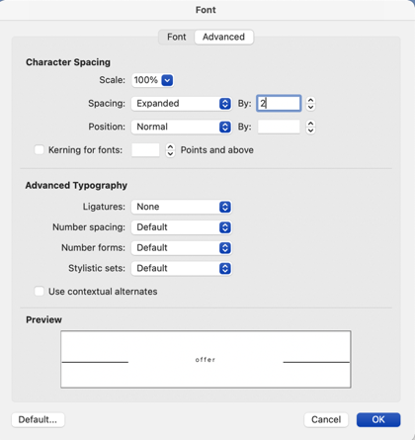
Address If Needed

Dear [FirstName],

FORMAT
Single space lines. Margins are .75in all around.

Headline - Ilisarniq Bold, size 12
Body copy – Ilisarniq Light, size 9

CAPTIONS— ILISARNIQ LIGHT / ALL CAPS / 2X LETTER SPACING / SIZE 9
(To do this, go to Format > Font > Advanced, then put “2” after Spacing Expanded By)

In this format you’ll likely mostly only be using Body Copy, so don’t get confused by the headlines and subheads if that’s not appropriate for what you’re creating. Here are a few other tips for making sure we all look nice and consistent.

Bolding content for emphasis is fine—italics are cool too—but please use all black (not colored) font.
Single is the new double—as far as spaces after a sentence are considered so don’t go crazy. One space after a sentence is plenty. And no indents are needed on paragraphs—let’s keep a clean line down the page. And finally, let’s all use the same bullet:
- Circles are a part of our new brand graphic design
- They look warm and go with the rounded lines on our logo
- Lookin’ good…

Together In Christ,

FULL NAME
Job Title

PS—Postscripts are often read first and are a great way to give a two second summary of what you want your reader to take away/do. So don’t be shy about getting in one last word.

