Logo Placement Details
If you’re dropping the logo onto a new document versus dropping content into this form template, here’s how to set up the logo as above:
Size: 1.5in Wide x .55in High
Position: .75in from left
.5in from top

Headline - Ilisarniq Bold, size 14
Body copy – Ilisarniq Light, size 9

CAPTIONS— ILISARNIQ LIGHT / ALL CAPS / 2X LETTER SPACING / SIZE 9
(To do this, go to Format > Font > Advanced, then put “2” after Spacing Expanded By)

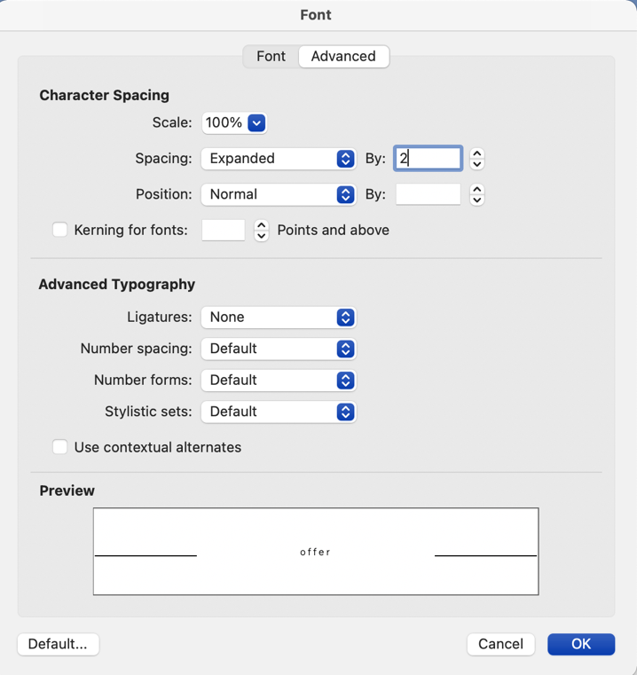

NOTE:
In the case of an application form or something with a large amount of text, please reduce the size of the headlines to size 9, as well.

